ENGL 002: Foundation English
Reading Strategies Module — Source Packet 4
Topic: Media Influence and Accountability — Group A
Central Tension: Individual vs. The Media
Framing Question: “Who should be held responsible when media coverage or platform-hosted content misleads, causes harm, or amplifies falsehoods – journalists, platforms, algorithms, or audiences themselves?”
How to Use This Packet
This packet brings together two credible sources on this topic: one scholarly, peer-reviewed source and one source from a reputable organization or publication. As you read, practice the strategies from this module: annotate key claims and evidence, summarize each source's main argument in your own words, and identify how each source relates to the framing question above.
You will submit this document with your annotations at the end of this module and you will use the information in this packet later in the course for your group presentation.

Reputable Source
Pew Research Center. (2025, October 29). How trust in info from news outlets and social media has changed over time. https://www.pewresearch.org/short-reads/2025/10/29/how-americans-trust-in-information-from-news-organizations-and-social-media-sites-has-changed-over-time/
Source type: Nonpartisan research organization (survey data)
Author / organization: Pew Research Center
Currency: October 29, 2025
Guided question 1: This survey found trust in national news organizations has dropped 20 points since 2016. What role might social media play in that decline?

Americans’ trust in information from national and local news organizations has declined after a slight increase earlier this year, according to a new Pew Research Center survey. The decline has occurred in both major political parties and across all age groups.
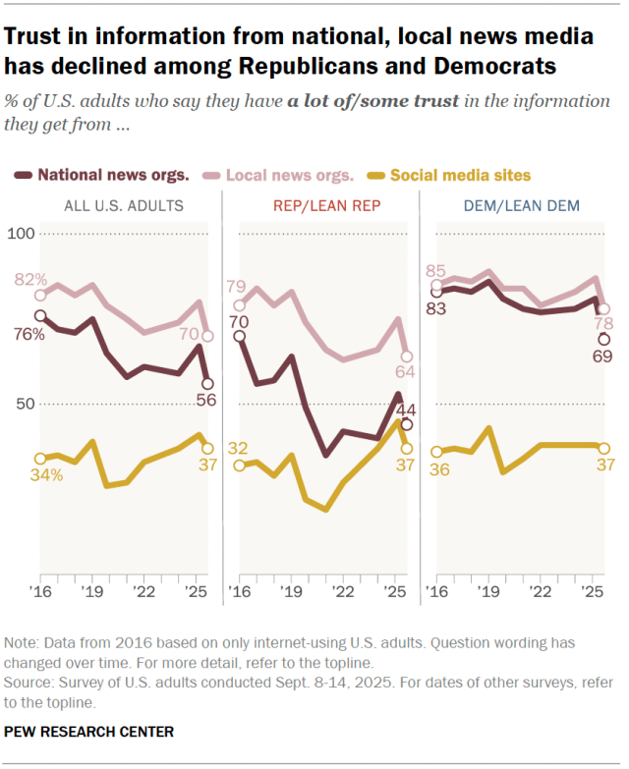
Overall, 56% of U.S. adults now say they have a lot of or some trust in the information they get from national news organizations – down 11 percentage points since March 2025 and 20 points since we first asked this question in 2016. The share of Americans who have at least some trust in information from local news organizations remains higher (70%), although it has also dropped – from 80% in March and 82% in 2016.
Fewer than half of Republicans and Republican-leaning independents (44%) now say they have at least some trust in the information that comes from national news organizations. This is down from 53% in March and 70% in 2016, but it’s still above its lowest point in 2021, when 35% of Republicans expressed this level of trust in the national media.
How we did this
Pew Research Center has asked Americans about their trust in information from national and local news organizations, as well as social media sites, since 2016. This research aims to better understand changes in trust over time and adds to our ongoing exploration of Americans’ views of the news media.
For this analysis, we surveyed 5,195 U.S. adults from Sept. 8 to 14, 2025. Everyone who took part in this survey is a member of the Center’s American Trends Panel (ATP), a group of people recruited through national, random sampling of residential addresses who have agreed to take surveys regularly. This kind of recruitment gives nearly all U.S. adults a chance of selection. Interviews were conducted either online or by telephone with a live interviewer. The survey is weighted to be representative of the U.S. adult population by gender, race, ethnicity, partisan affiliation, education and other factors. Read more about the ATP’s methodology.
Here are the questions used for this analysis, along with responses, and its methodology.
When it comes to local news organizations, Republicans are more trusting (64% have at least some trust), although the share who trust local media has also eroded from 75% in March and 79% in 2016.
As in the past, Democrats (including leaners) are more likely than Republicans to trust information from national and local news organizations. But Democrats’ trust in both types of organizations has also fallen in recent months. Today, 69% of Democrats have at least some trust in information from national news organizations. This is the lowest level recorded since we began asking the question, and down from 81% in March. Meanwhile, 78% have this level of trust in information from local news organizations, down from 87% earlier this year.
Republicans and Democrats are equally likely to say they have at least some trust in information from social media sites (37% in each group say this). Republicans are now less likely to trust this information than they were earlier this year (down 8 percentage points) after a period of steady increase. The share of Democrats who say they have at least some trust in information from social media sites has remained relatively consistent over the past several years.
Trust in national and local news media declines across all age groups
Americans under 50 are slightly less likely than those ages 50 and older to have trust in information from national and local media. Still, across all age groups, trust in these organizations has declined over the last several months.
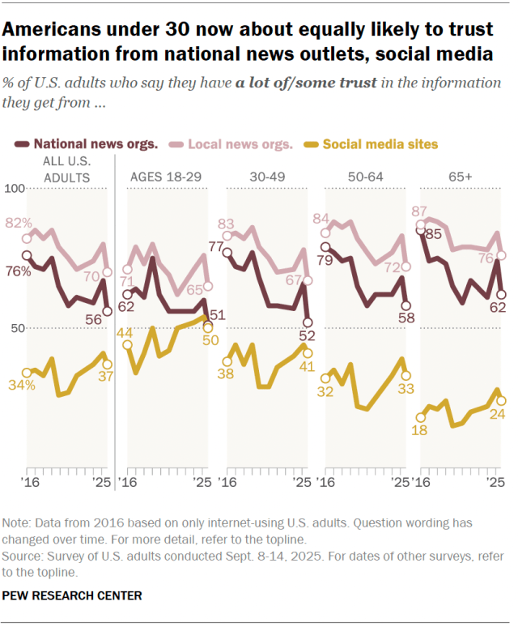
Today, only around half of adults under 50 (52%) have a lot of or some trust in information from the national news media. Adults under 30, in particular, are now about as likely to say they trust information from national news organizations (51%) as they are to trust information from social media sites (50%). Older age groups, in turn, are more likely to trust national news organizations than social media.
Trust in local news organizations remains higher than trust in national news organizations among Americans of all ages.
Younger Democrats express less trust than older Democrats in national and local news
Trust in national and local news organizations also varies by party and age, especially among Democrats.
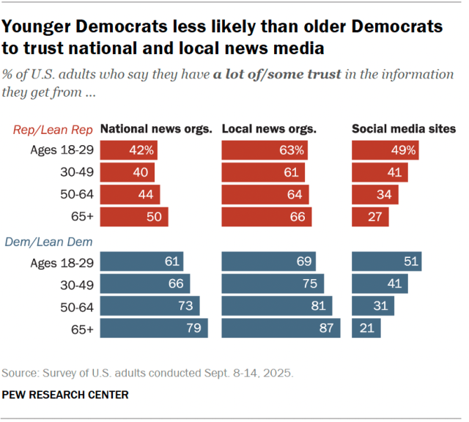
In the new survey, 79% of Democrats ages 65 and older say they have at least some trust in information from national news organizations. This falls to 73% among Democrats ages 50 to 64, 66% among those 30 to 49 and 61% among those under 30. The pattern is similar when it comes to trust in local news organizations: Older Democrats express more trust than younger Democrats.
Among Republicans, age differences are less pronounced. Half of Republicans 65 and older, for instance, say they trust information from the national news media. This figure falls to 42% among Republicans ages 18 to 29. And between 61% and 66% of Republicans in all age groups say they trust information from local news organizations.
Note: This is an update of an analysis originally published on Oct. 27, 2022. Here are the questions used, along with responses, and its methodology.

Source 2 · Scholarly Source
Almakaty, S. S. (2025). Agenda setting theory in the digital media age: A comprehensive and critical literature review. Future Technology, 4(2), 51–60. https://doi.org/10.55670/fpll.futech.4.2.6
Source type: Peer-reviewed journal article (open access)
Author / organization: Safran Safar Almakaty, Imam Mohammad ibn Saud Islamic University
Currency: 2025 — covers research from 2004 to 2024

Agenda setting theory in the digital media age: a comprehensive and critical literature review
Safran Safar Almakaty*
A B S T R A C T
This thorough literature study looks at how Agenda Setting Theory (AST) has developed in the digital media era over the last two decades (2004-2024). From its beginnings in McCombs and Shaw's work, the study tracks AST's evolution across three levels: issue salience transfer, attribute agenda setting, and the more recent Network Agenda Setting model. It examines how digital media's qualities- fragmentation, interactivity, algorithmic curation, and decentralized gatekeeping- have challenged and altered conventional agenda-setting mechanisms. Based on about 40 studies, the analysis concludes that although agenda-setting impacts remain online, they function in a more complicated, networked manner with a broader spectrum of players affecting public agendas. The article investigates digital platforms' empirical data, the rise of new agenda-setting players outside conventional media, and issues including audience fragmentation and false information. AST is still shown to be relevant, but major adjustments are needed to grasp the several aspects of agenda creation completely in today's mixed media environment.

Introduction
Famously defined by Maxwell McCombs and Donald Shaw [1], Agenda Setting Theory (AST) claims that the news media shapes the public's view of the relevance of specific problems by choosing and prominently showing them. "The media may not be successful much of the time in telling people what to think, but it is stunningly successful in telling its readers what to think about," the basic maxim of Cohen (1963, p. 13, as referenced in [2]), embodies the theory's foundational first level. Later studies concentrated on attributing agenda setting- how media framing shapes public perception of the qualities or features of those concerns and public figures- thereby extending this to a second level [3]. More lately, a third level, Network Agenda Setting (NAS), looks at the interrelationship of topic and attribute agendas throughout the media and public spheres [4]. Primarily in the context of conventional mass media- newspapers, television news- AST has offered a strong framework for grasping media influence for decades. The communication environment has been drastically changed by the birth and fast development of the digital media era marked by the internet, social media platforms, mobile technologies, user-generated content (UGC), algorithmic curation, and dispersed audiences. This change calls for a thoughtful re-evaluation of AST's relevance, tools, and breadth. When media gatekeepers are distributed, viewers are active content producers and selectors, and information travels through complicated, sometimes algorithmically mediated networks, is the idea still relevant?

Aiming to be thorough and critical, this literature review offers an overview of scholarly work produced within the last two decades, roughly 2004 to 2024, that explores Agenda Setting Theory in this digital media environment. It investigates how well the fundamental principles of AST hold up, points out essential changes and extensions suggested by academics, looks at the part played by new actors and technological affordances, and addresses the issues and subtleties brought about by events including social media, algorithmic filtering, and the dissemination of false information. This paper aims to chart the present state of knowledge on agenda-setting processes in an increasingly complicated and participative media ecosystem by combining results from about 40 studies. The review is organized into chapters examining the foundations, the digital challenges, empirical evidence from the digital sphere, the rise of Network Agenda Setting, the role of new actors and influences, and the ongoing issues of fragmentation and misinformation, ending with a summary and recommendations for future research. Therefore, this literature review aims to critically examine the evolution and adaptation of Agenda Setting Theory (AST) within the digital media context over the past two decades (2004–2024). Specifically, the study investigates how digital media characteristics such as fragmentation, interactivity, algorithmic curation, and decentralized gatekeeping challenge traditional agenda-setting processes (Table 1).

Furthermore, it evaluates the emergence and significance of new agenda-setting actors and explores issues such as audience fragmentation and misinformation, thereby assessing the continued relevance of AST in contemporary media ecosystems [4].

2. Foundations of agenda setting theory
It is important to quickly review the basic ideas of Agenda Setting Theory (AST) before exploring the digital age's complexity. Originally concentrating on the transfer of problem salience (Level 1) from the media agenda to the public agenda, AST was born from the groundbreaking Chapel Hill study [13]. McCombs and Shaw discovered a close link between the concerns highlighted by the news media and the ones voters said were most significant by means of media content analysis and polling of undecided voters during the 1968 US presidential election. This result called into question the dominant "limited effects" model of media influence by implying a significant cognitive effect: the media influences our awareness and priorities on societal concerns. Numerous studies replicating and extending the theory's results across many settings and nations [14,15] helped it gain popularity quickly. Researchers investigated several situational factors affecting the intensity of agenda-setting impacts, including the need for orientation (NFO)- a person's relevance perception and problem ambiguity [7]. People with greater NFO were found to be more vulnerable to media agenda-setting influences. The evolution of the second level of agenda setting signaled a notable theoretical growth. It went from what concerns are deemed essential to how those concerns- and related things like political candidates- are seen. This degree suggests that the public's knowledge and assessment of certain issues or objects is shaped by the media's emphasis on certain qualities, features, or frames in their reporting [15, 16]. Media coverage stressing economic factors of immigration as opposed to humanitarian ones, for example, might influence public perception of the essential qualities of the problem and possible remedies. Research showed a link between the prominence of characteristics in media coverage and the prominence of those same traits in public opinion. Though there are clear variations, mostly AST's emphasis on salience transfer, this degree linked AST more closely with framing theory [17]. Often mentioned are the fundamental assumptions supporting conventional AST:
• Editors and reporters among somewhat centralized media gatekeepers decide on news selection and visibility.
• Especially from elite national news sources, a quite noticeable and somewhat common media agenda.
• A most passive audience that consumes media rather than creates or actively curates it on a mass basis.

Table 1. Evolution of agenda setting theory (AST)
Period | Focus | References
First-Level Agenda Setting (1972) | Issue Salience Transfer. Media emphasizes certain issues, influencing public perception of issue importance | [5]
Second-Level Agenda Setting (1995-1997) | Attribute Salience (Framing). Media framing influences public perception of issue attributes and evaluations | [6]
Digital Media Emergence (2000s) | Rise of internet-based platforms challenges traditional agenda-setting due to fragmentation, interactivity, and decentralized gatekeeping | [7]
Network Agenda Setting (NAS) (2011) | Paradigm Shift: Introduction of networked perspective; salience transfer viewed as interconnected issue networks rather than isolated issues | [9]
Empirical Validation of NAS (2014-2020) | Studies empirically confirm NAS models in digital environments, highlighting interaction between traditional media, digital media, and public agendas | [10]
Contemporary Applications & Challenges (2020s & beyond) | NAS applied contemporary issues like misinformation, algorithmic curation, and influencer-driven agenda setting, underscoring the complexity and multidimensional nature of modern media influence | [11,1

3. The digital media landscape and its challenges to traditional agenda setting
The shift from an era ruled by conventional mass media to the present digital media age poses basic questions for the assumptions and processes of conventional AST. Several important aspects of the digital environment could interfere with or change agenda-setting mechanisms.
First, the growing number of media sources and channels causes media fragmentation [30]. Unlike the small number of powerful newspapers and television networks in the past, people now have access to a practically limitless range of niche publications, social media feeds, blogs, online news sites, and more. This considerably complicates the definition of a single, consistent "media agenda."

Table 2. Three levels of agenda-setting theory
Attribute | First-Level Agenda Setting(Issue Salience) | Second-Level Agenda Setting(Attribute Salience) | Third-Level Agenda Setting(Network Agenda Setting, NAS)
Focus | "What" issues or topics are presented as important in the media agenda [18]. | "How" these issues, topics, or entities are framed; the attributes emphasized by media [19]. | Relationships and interconnections among multiple issues and attributes in media and public agendas; network structures and dynamics [20].
Primary Influence | Shapes public perception of issue importance and priority through selection and prominence given to topics [22]. | Influences how the public thinks about specific issues or entities by highlighting attributes, characteristics, or frames [21]. | Influences public understanding by structuring interconnected "issue networks," shaping how issues are cognitively linked and perceived as related [4, 23].
Effects | Transfer of issue salience from media to public; people perceive media-highlighted topics as most important (cognitive effect) [24]. | Transfer of attribute salience; public perceptions and evaluations of issues or entities are shaped by emphasized attributes (framing effects; evaluative effect) [25]. | Transfer of relationships among issues and attributes; public perceptions of how issues interrelate mirror media-generated issue networks (complex, cognitive, relational effect) [26].
Media Environment | Traditional mass media (newspapers, TV news) initially dominant; linear, hierarchical transfer of salience [27]. | Traditional mass media with increasing relevance in mediated environments; still linear but more nuanced and evaluative [2, 28]. | Digital, fragmented, interactive, algorithmically curated media; networked, non-linear, dynamic interactions and exchanges among multiple actors
The possibility of a common public agenda created by media agreement declines if viewers are spread across many venues with different material objectives [31].

Second, user-generated content (UGC) and interactivity change the relationship between media providers and consumers. No longer passive consumers, users actively produce, distribute, comment on, and remix material [32]. By allowing people and non-elite organizations to voice concerns and influence stories, platforms like Twitter, Facebook, YouTube, and TikHub may be able to completely avoid conventional media gatekeepers. This begs the question of who determines the agenda: Is it still legacy media, or do online influencers, citizen journalists, or collective public emotion on social platforms now have major agenda-setting power [33].

Third, personal media exposure is more and more shaped by algorithmic selection. Based on user behavior, interests, and network connections, search engines (Google), social media feeds (Facebook's News Feed, Twitter's timeline), and news aggregators (Apple News) employ sophisticated, often opaque algorithms to tailor information delivery [34]. This customization might create "filter bubbles" or "echo chambers" in which people are mostly exposed to information supporting their current opinions, hence restricting exposure to different points of view and impeding the development of a wide public agenda [18]. Moreover, the algorithmic logic itself, giving engagement or recency top priority, could influence the perceived relevance of problems differently from conventional journalistic news values [35].

Fourth, the fall of conventional gatekeepers changes the power structure. Although journalists and editors in legacy media continue to have some influence, their capacity to set the news agenda is debatable [36]. While powerful people and networked communities have a great influence, online platforms have their own kind of gatekeeping (algorithmic

Fifth, information flow's speed and architecture have evolved. News and information can spread virally across networks in minutes or hours, causing quick changes in attention [38]. The networked system enables intricate interconnections between several agendas- media, public, and policy, which conventional linear models of agenda setting battled to grasp [39].
Collectively, these traits- fragmentation, interactivity, UGC, algorithmic curation, decentralized gatekeeping, and faster, networked information flows- challenge the conventional AST framework. They make the measuring of media and public agendas more difficult, bringing new powerful players into play, changing the processes of salience transfer, and creating questions about the possibility of polarization and manipulation. Later chapters will investigate how empirical studies have struggled with these issues, evaluating AST's durability and adaptation in this changed context.

4. Empirical evidence: agenda setting effects on the digital sphere
A significant number of empirical studies conducted throughout the last two decades show that, in different ways, agenda-setting influences remain online despite the theoretical difficulties the digital media environment presents. The platform, the user, and the setting all determine the character and intensity of these impacts. Many studies show that through their internet platforms, conventional news outlets still have agenda-setting power. While blogs exhibited some independent agenda power, Meraz [40] discovered that conventional media websites nevertheless had a major influence during the 2004 US election. Likewise, Lim [41] showed first-level agenda-setting impacts for online publications in Singapore. Online news exposure on political candidates led Conway et al. [42] to discover first- and second-level agenda settings as well as second-level agenda
settings. This implies that even when consumed online, established news brands keep impact and credibility.

Vargo et al. [43] found a significant flow of influence from legacy media, such as the New York Times, to online news aggregators and blogs, implying that conventional media still typically establish the first agenda that spreads into the digital world. Digital agenda-set studies have increasingly concentrated on social media channels. Often examined has been Twitter, which is used by journalists, lawmakers, and the public, and has a real-time character. Several studies indicate that Twitter can affect the public agenda [28, 44] and the conventional media agenda (intermedia agenda setting) to some level. For instance, trending topics on Twitter or powerful users could push news organizations to report on matters. Particularly at the attribute level (Level 2), Harder et al. [45] discovered reciprocal interactions between Twitter agendas and media agendas. The results are complicated, though; other studies indicate Twitter mostly reflects and magnifies current media agendas instead of directly creating them [46]. Though user involvement and network structures are very important, studies on Facebook indicate its news feed algorithm can affect issue salience [47, 48]. Investigations have also been made on search engines, especially Google, as possible agenda setters. Studies indicate that search engine results may affect user views of problem significance and even candidate choice [49]. Search results' order indirectly gives importance, thereby acting as a strong but subtle kind of agenda framing [50].

The data, meanwhile, is not consistent. Several studies show online agenda-setting effects that are weaker or altered. The high-choice environment may reduce the power of conventional media to establish a consistent public agenda by allowing consumers to selectively skip news or subjects they find uninteresting or objectionable [51]. Moreover, for certain demographics, especially for younger audiences or the politically involved who actively search for information online, the impact of online sources may be more noticeable [52]. Studies also show the growing relevance of second-level (attribute) agenda framing in the digital domain. Often, with comments and emotional signals, the way social media discusses frames and shares problems can greatly influence how those problems are viewed [53]. The viral adoption of certain hashtags or memes linked to an issue can quickly create dominant characteristics or frames in online conversation. To sum up, empirical data indicates that agenda setting is not dead in the digital era but rather more complicated and multifarious. While traditional media still have online power, social media, search engines, and user behavior create new dynamics. Often, the consequences are dependent, networked, and maybe more powerful at the attribute level than the problem level in relation to the conventional media age.

5. The rise of network agenda setting (NAS)
Acknowledging the shortcomings of conventional linear models in reflecting the complexity of the digital media ecosystem, scholars created the Network Agenda Setting (NAS) model, sometimes called the third level of agenda setting [54]. NAS changes the emphasis from the straightforward transfer of salience between two agendas—e.g., media to public—to investigating the relationships among a network of components (issues or qualities) inside and across several agendas. It suggests that problems and qualities are linked rather than separate and that the perceived significance of one item affects the relationship with others. According to the NAS model, media coverage creates networks of problems and characteristics that can shape the development of comparable networks in the public's perception [55]. Media coverage, for instance, could regularly connect the problem of "immigration" with qualities like "national security" and "economic impact," while linking "healthcare reform" with "affordability" and "access." NAS theorizes that the pattern of these relationships in media coverage will reflect the pattern of how the public perceives these concerns.

NAS studies thrive in the digital environment, with its hyperlinked structure and networked communication flows (social media connections, retweets, shares). Network analysis methods have been used in studies to map these connections. Vargo et al. [56] examined Twitter (UGC), political blogs, and conventional media for issue networks connected to US healthcare reform. They discovered notable relationships between the problem networks found in these various media domains, hence validating the NAS model and showing the movement of issue connections between channels. Guo [57] showed how various media sources build separate networks of characteristics surrounding prominent individuals, hence shaping public opinions. Moreover, NAS lets one dynamically grasp agenda setting by including intermedia agenda setting (how various media affect one another) and reverse agenda setting (how media coverage is influenced by public or group agendas) all under one framework. For example, popular themes or viral campaigns starting on social media (public/community agenda) might drive conventional media sources to report on a matter, hence showing a flow from the public network to the media network [58]. Vu et al. [59] offered proof of this dynamic interaction across blogs, internet media, and legacy media influencing the general problem agenda network.

Studies have also looked at how various media forms help the network in different ways. While social media could highlight certain qualities or emotional aspects within the network, traditional media could create core issue links [60]. Examining network agenda setting among young people, Kligler-Vilenchik and Tenenboim [61] discovered that peer networks and alternative internet sources significantly influence their problem maps alongside conventional media. A major theoretical development, the NAS model provides a more complex and complete approach to thinking about agenda formation in the digital age's interconnection. Reflecting the complicated reality of information flow in networked societies, it goes beyond basic salience transfer to examine the structure of relationships between agenda items. Although methodologically challenging (requiring content analysis paired with network analysis), NAS offers an insightful study of how meaning and salience are created and distributed inside the modern hybrid media environment.

6. New actors and influences: beyond traditional gatekeepers
Beyond the conventional emphasis on legacy news outlets, the digital media ecosystem has broadened the spectrum of players who might influence media and public agendas. This chapter investigates the agenda-setting functions of these new players and the simultaneous increase of user agency. Political actors increasingly use digital platforms to bypass conventional media middlemen and set their own agendas straight with the public [62]. Influencing public opinion and later media coverage, politicians declare policies, express concerns, criticize rivals, and rally supporters via Twitter, Facebook, and other channels [63]. This direct communication questions conventional intermedia agenda setting, whereby politicians frequently depend on media coverage to contact the people. Conway et al. [64] proved this dynamic change by finding that tweets from political figures could shape media agendas. Particularly for certain demographics or niche issues, social media influencers- people with substantial online followings who sometimes work outside conventional journalistic standards- have become major agenda setters [65]. Often concentrating on lifestyle or consumerism, influencers can also highlight social or political concerns, hence influencing their relevance and characteristics within their networks [66]. Their agenda signals may be stronger given their perceived genuineness and relational connection with followers.

Often pushing concerns into the mainstream media and political agendas, citizen journalists and activists use digital technologies to record events, spread alternative stories, and organize group action [67]. Movements such as the Arab Spring or #BlackLivesMatter showed the strength of networked people using social media to question official narratives and create agendas from the ground up [68]. Even non-human entities, particularly algorithms, have a significant gatekeeping and agenda-influencing impact [69]. Rather than conventional news values, the algorithms curating social media feeds, search results, and news aggregators determine the visibility and prominence of information, implicitly setting an agenda based on programmed criteria (e.g., engagement, personalization, recency) [70]. Often unnoticed by consumers, this "algorithmic agenda setting" generates questions regarding openness and possible prejudices. At the same time, the digital era enables user agencies in ways that were previously unheard of. Users actively participate in selective exposure, not only passively receiving but rather choosing sources that fit their interests and values [71]. They also engage in selective sharing and commenting, highlighting messages and qualities while downplaying others, so co-constructing agendas in their networks [72]. News feed customization options let users create their own information environments, hence perhaps generating individual agendas [73].

Increased user agencies challenge conventional agenda-setting theories. User decisions and activities inside digital networks greatly mediate the reception and spread of media and other actors' agenda-setting efforts, even as they continue to do so [74]. The general agenda-setting process turns into a more dynamic, negotiated event including traditional media, new players (political elites, influencers, activists, algorithms), and active consumers involved in selection, interpretation, and sharing.

7. Challenges and nuances: misinformation, algorithms, and fragmentation
Although earlier chapters underlined the ongoing and adaptive agenda-setting online, this one emphasizes notable digital age complexities and challenges: audience fragmentation, the widespread impact of algorithms, and the intentional dissemination of false information and disinformation. Driven by the high-choice media environment, audience dispersion remains a primary worry [75]. Although others contend that fragmentation is overstated and shared experiences endure [76], the possibility for people to live in quite diverse information universes is genuine. Any actor's (media or otherwise) capacity to establish a generally shared public agenda may be weakened by this. Rather, several, occasionally contradictory, agendas could coexist among various demographic segments, hence aggravating political and social polarization [18]. Tewksbury and Rittenberg's [77] study indicates that although fragmentation happens, its effect differs depending on people's media consumption habits and goals. Algorithms' influence on information flow curation presents difficulties. Designed to increase user involvement, algorithmic personalization might unintentionally foster "filter bubbles" [78] or "echo chambers" [79], therefore strengthening existing opinions and limiting exposure to various perspectives. While the empirical extent of these phenomena is debated [80], algorithms undeniably act as powerful, non-transparent gatekeepers that shape the salience of issues and attributes based on criteria other than journalistic judgment [81]. This begs for important issues regarding responsibility and the possibility of algorithmic bias distorting the perceived public agenda.

One of the most urgent issues could be the influence of false information and disinformation on the digital agenda-setting process. Social networks can quickly propagate false or misleading information, often magnified by automated accounts (bots) and coordinated campaigns [82]. Such material might purposefully try to establish different agendas, divert attention from crucial concerns, or influence unfavorable qualities linked to groups or subjects [83]. Research indicates that fake news travels quicker and farther than real news, hence seriously endangering educated public debate [84]. Competing, often deliberately deceptive, agendas make the conventional AST emphasis on the transfer of salience from reliable news sources more difficult. Though consequences can be complicated [85], research is progressively concentrating on the mechanisms by which false information shapes public opinion and how interventions such as fact-checking affect these dynamics. These issues- fragmentation causing several agendas, unclear algorithmic curation affecting information exposure, and intentional dissemination of false information- emphasize the difficulty of researching agenda setting in the present. They emphasize the need for research designs considering individual media diets, algorithmic effects, and the truth of information spreading inside networks. A still important front for agenda-setting studies is knowing how these elements interact and influence public perception.

8. Discussion
Over the last two decades, this literature review has investigated Agenda Setting Theory's (AST) evolution and implementation in the digital media context. The results show both continuity and change in how agenda-setting mechanisms work, hence implying some important topics deserving of more debate. Perhaps the most remarkable result is the ongoing impact of agenda-setting in digital settings. Empirical data regularly shows that, despite significant technological and structural changes in media ecosystems, the transfer of salience- from media to public agendas and within different media platforms- still happens [86]. This implies AST's underlying understanding of media's influence on determining perceived problem significance stays basically correct. These impacts, however, now show more complicated mechanisms and routes than conventional models included, hence reflecting what Neuman et al. [87] call the "dynamics of public attention" in a large data environment. Researchers have clearly shown the necessity for theoretical extension as they have created the Network Agenda Setting (NAS) model to more accurately reflect the interrelated character of modern agenda setting. Examining networks of related problems and qualities beyond linear salience transfer offers a more complex way to grasp how meaning is created and communicated in networked settings [88]. The advent of the NAS model is not only an incremental improvement but also a qualitative change in our understanding of agenda-setting processes from separate, hierarchical transfers to intricate, interrelated webs of influence. This development mirrors larger theoretical trends in communication research toward network-based strategies [89].

The diversification of agenda-setting actors is yet another important change. Though they now function under a power-sharing framework including political players, social media platforms, influencers, activist networks, and algorithms, traditional media companies still hold great influence [90]. This multiplication of possible agenda setters provokes significant normative issues regarding responsibility, openness, and democratic debate. The consequences for informed citizenship become troubling when algorithms with commercial goals or coordinated disinformation efforts can greatly affect the creation of the public agenda [91]. The study indicates that we want more complex models to grasp how these various players interact, compete, and occasionally cooperate in forming public attention. User agencies' increased importance is yet another key topic. Through techniques of selective exposure, filtering, sharing, and commenting, digital audiences actively shape agendas [92]. This results in a more negotiated, co-constructed process whereby audience reception and amplification determine the agenda-setting power of conventional media. Research shows that although user decisions, social networks, and technology affordances increasingly mediate this transfer, issue salience can nevertheless move from media to public agendas. This result links AST studies with literature on participatory culture and networked publics, hence implying fruitful paths for cross-fertilization. The studies, however, raise major obstacles to common public objectives. All could compromise the development of a shared, fact-based knowledge of society goals: audience fragmentation, echo chambers, filter bubbles, and the dissemination of false information [93]. Although some studies indicate these issues might be exaggerated [94], the possibility of ever more tailored and algorithmically managed information environments enabling various, often conflicting public agendas remains a major worry. The high-choice media environment lets people create quite distinct information universes, as Tewksbury and Rittenberg [95] point out, which may aggravate polarization and make democratic administration more difficult.

9. Conclusion
Over the past two decades, Agenda Setting Theory (AST) has shown adaptability within the evolving digital media environment. Despite significant technological and structural changes, the core concepts of AST—issue salience (Level 1) and attribute salience (Level 2) transfer—remain relevant. Research indicates that traditional media still retain agenda-setting influence online, while social media and search engines introduce new dynamics, requiring a departure from linear models. The Network Agenda Setting (NAS) model has enhanced the theoretical framework by capturing the interconnected nature of issues and attributes across various media and public agendas. This networked perspective reflects the complexity of online communication and provides a stronger foundation for understanding agenda formation in digital contexts. The diversification of agenda setters, including political actors, influencers, algorithms, and networked publics, challenges the traditional dominance of legacy media gatekeepers. These actors, along with the rise of active user participation through selective exposure, sharing, and commenting, have made agenda-setting a more participatory and negotiated process. However, challenges such as audience fragmentation, echo chambers, algorithmic curation, and the spread of misinformation pose risks to forming a shared, informed public agenda. Future research should focus on cross-platform agenda-setting dynamics, the ethical implications of algorithmic influence, and the impact of misinformation. Additionally, global studies are needed to examine AST's applicability across different cultural and media environments. Despite these challenges, AST remains a valuable framework for understanding media influence, demonstrating its resilience and adaptability in the complex digital media landscape.

Summary

Source 1: Pew Research Center

Public confidence in both national and local news institutions has suffered widespread decline in all political affiliations and age brackets. Even if local news outlets maintain a higher trust overall, compared to national outlets, both sectors reached a historical low in the late 2025. A major demographic shift is evident among adults under 30, who place equal trust in social media platforms and traditional news outlets. These findings overall, highlights how digital platforms eroded the singular power held by the legacy news gatekeepers.

Source 2: Almakaty

For the past two decades, digital developments such as algorithmic curation and user interactivity have reshaped traditional agenda setting. While traditional journalism retains online influence, the Network Agenda Setting model shows modern public priorities are formed through interconnected webs of issues rather than a straight clear communication. However, non-traditional actors can now actively create and negotiate public attention. Eventually, audience fragmentation and misinformation flows complicate the creation of a unified societal consensus in today’s media environment.

Answering Framing Question

Source 1: Pew Research Center

This source shifts responsibility towards platforms, algorithms and audiences. As trust in traditional journalism drops across all demographics, younger audiences rely on social media feeds where algorithms curate content without traditional factchecking. This suggests the harm and falsehoods which stems from less journalism malpractice and more from platform mechanics and audiences choosing unverified feeds over established news organizations.

Source 2: Almakaty

This source shows that accountability is shared across the entire media network rather than belonging to a single group. By establishing that modern media agendas are created by journalists, political elites, and influencers who share content, Almakaty proves that when harm or misinformation occurs, it’s the result of a complex, interactive system rather than legacy news outlets alone.

